Hand in 8

Task 1
a)
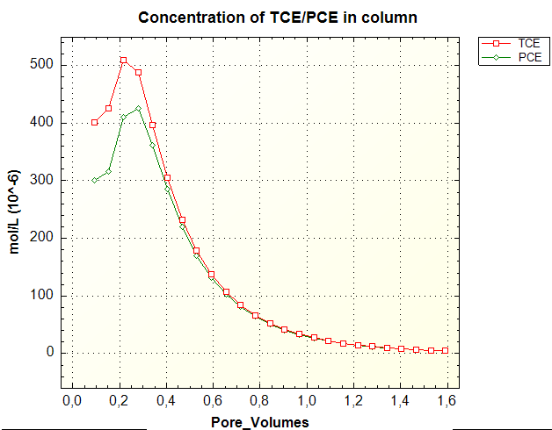

As can be seen in figure 2, it takes some time before the TCE and PCE breaks through, with the concentration increasing for the first 0.2-0.25 pore volumes. It can also be observed that PCE brakes through later than TCE, the same result was obtained in the original paper. After around 1 pore volume most of the PCE and TCE are out of the solution.

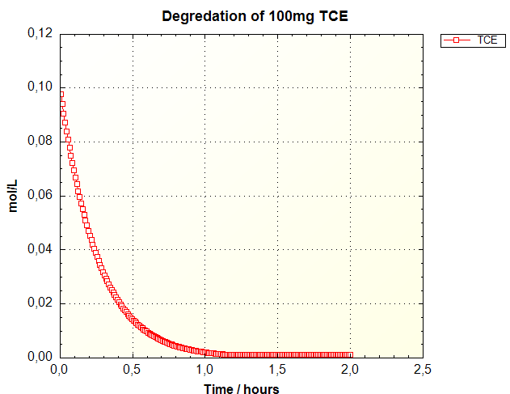
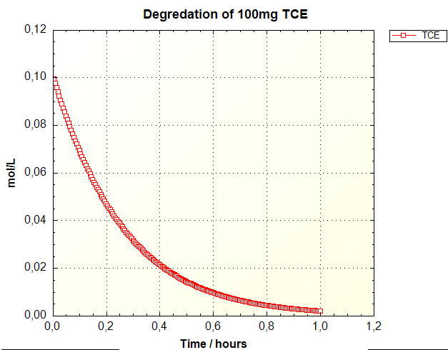
b)

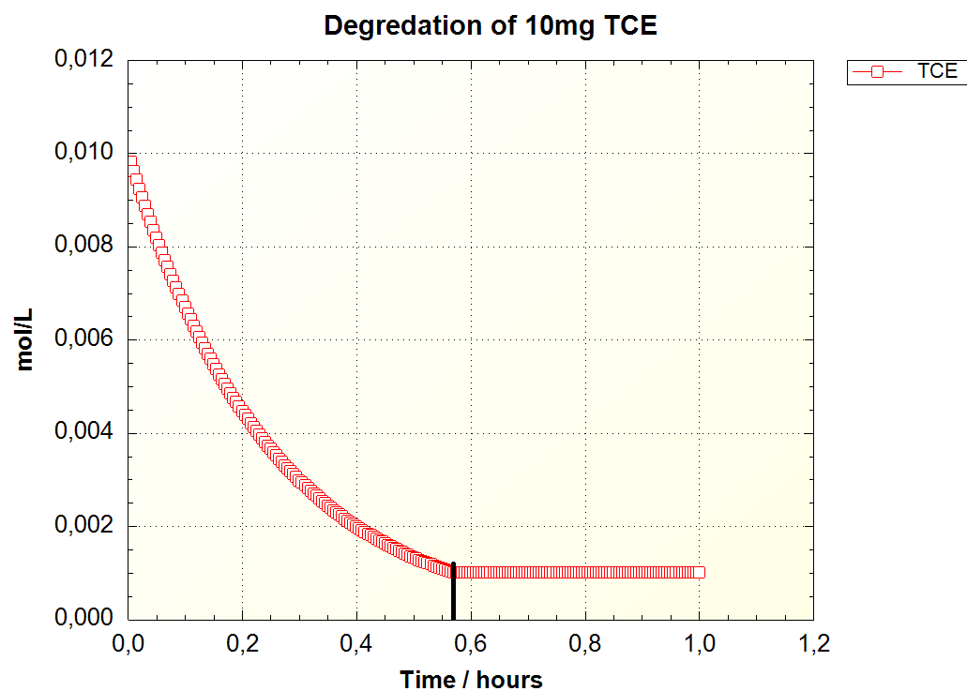
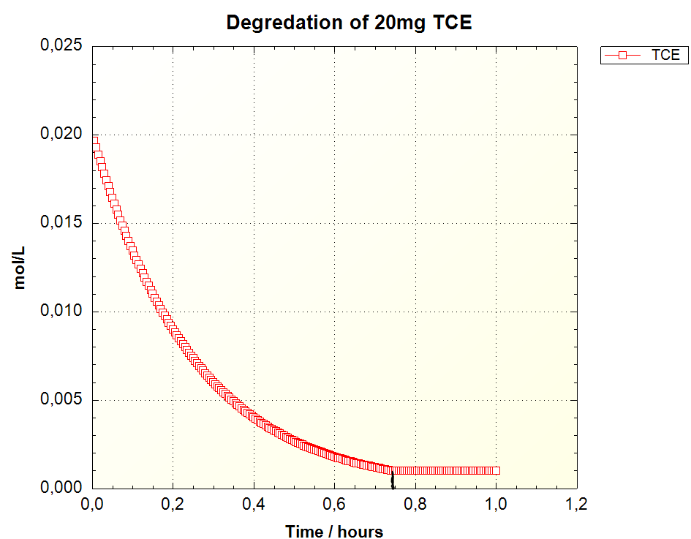

In
figures 2-5 the degradation of TCE has been calculated using a K_max value of 124 mmol/mg/day. K1/2 values was obtained from the solubility limit. All values were found in Sabalowsky & Semprini 2010.
Using the method found in example 10.7, it does not seem to matter what the initial concentration was, and all the figures show the same degradation, all using about one hour to degrade. Using an if statement, the model stops calculating the concentration of TEC after reaching a concentration of 0.001 mol/L. For the 100mg/L solution, the cutoff occurs after 70 minutes, as can be seen in figure 3. For the 20mg/L solution, the cutoff happens after 45 minutes, while for the 10mg/L solution, the cutoff happens after approximately 36 minutes. The degradation, using the rate function, will have exponentially higher degradation as the concentration is raised

Sources:
Sabalowsky, A. R. & Semprini, L. (2010) - Trichloroethene andcis-1,2-dichloroetheneConcentration-Dependent Toxicity Model Simulates AnaerobicDechlorination at High Concentrations: I. Batch-Fed Reactors
(https://scholarworks.montana.edu/xmlui/bitstream/handle/1/13107/10-040_Trichloroethene_and_cis-1_.pdf;jsessionid=58F5DAF55681380CA519EFCD8C718FB9?sequence=1)

